**Fatima Jinnah Women University**

Department of Software Engineering

**LAB 3**

**Name:** Raifa Khalid

**Reg. no:** 2020-BSE-024

**Section:** A

**Semester:** Fourth

**Course:** Data Base (LAB)

**EXAMPLES:**

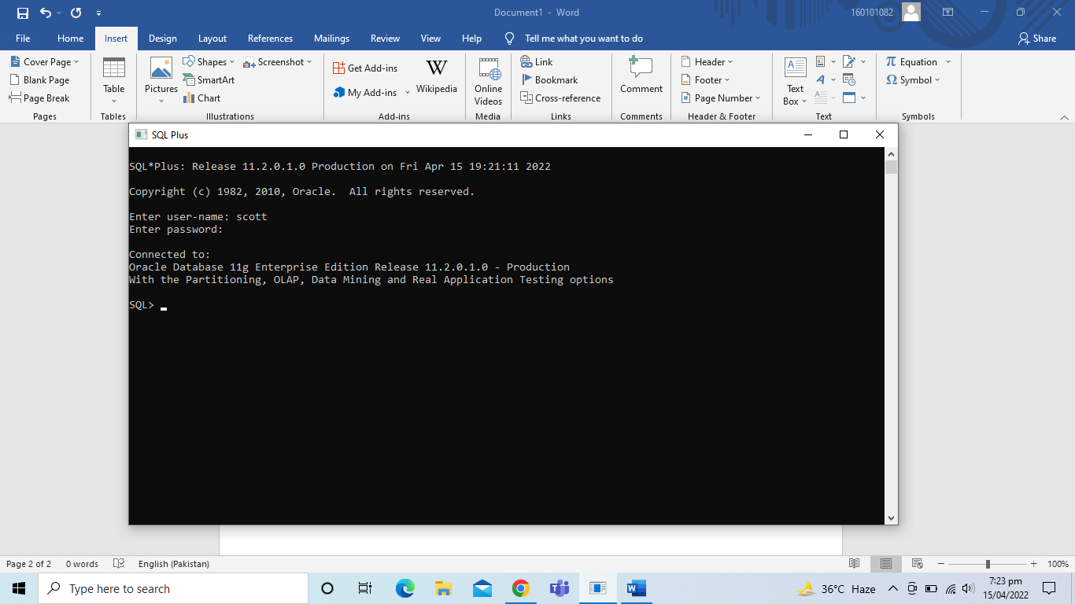

*Selecting User Tables:*

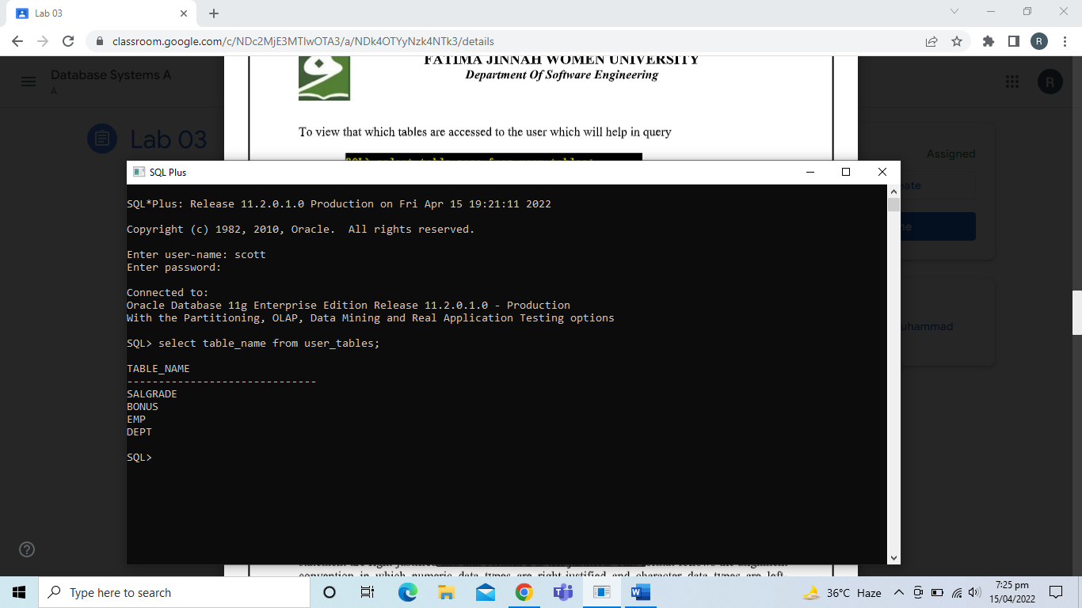

*Describing Table Schema:*

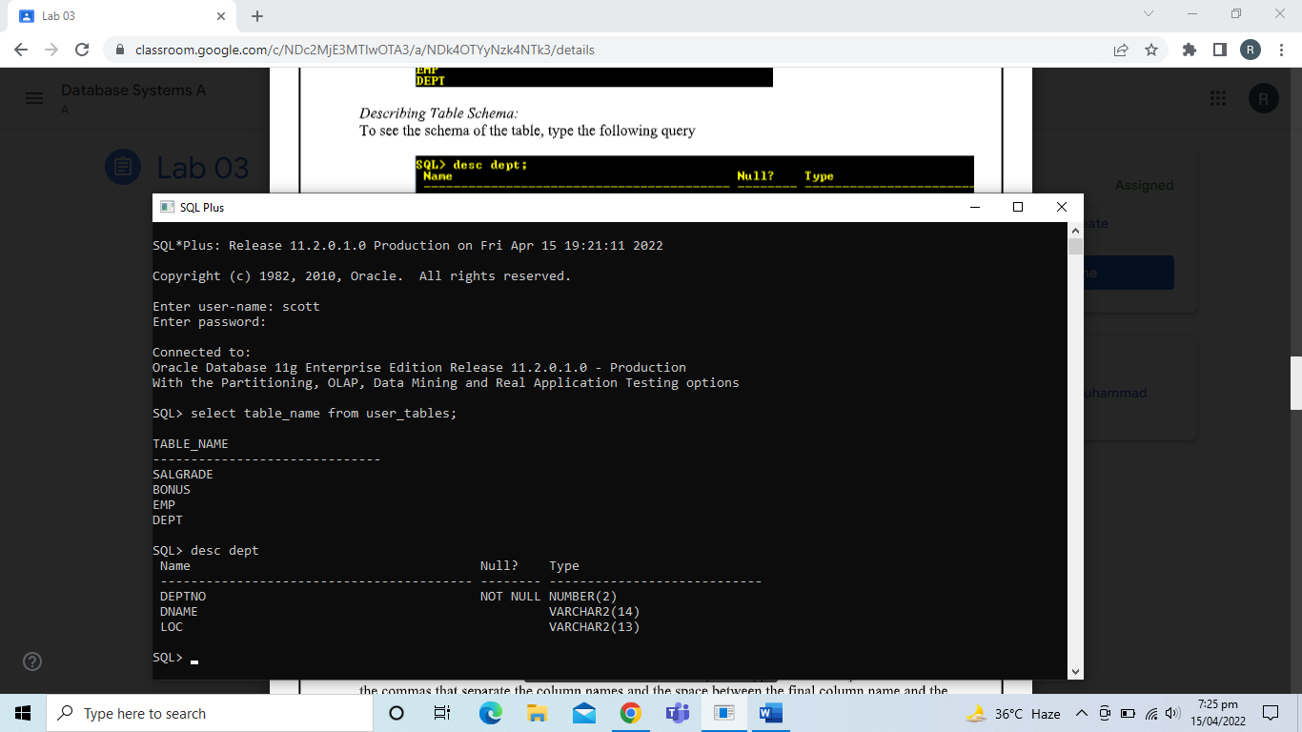

*Selecting all Columns:*

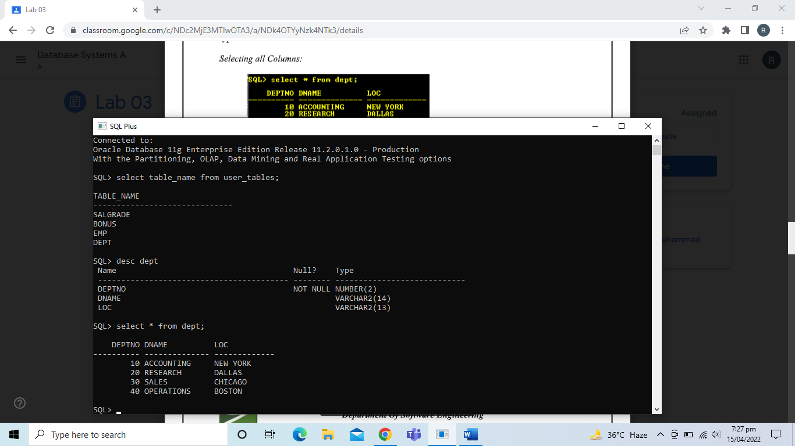

*Selecting Specific Columns:*

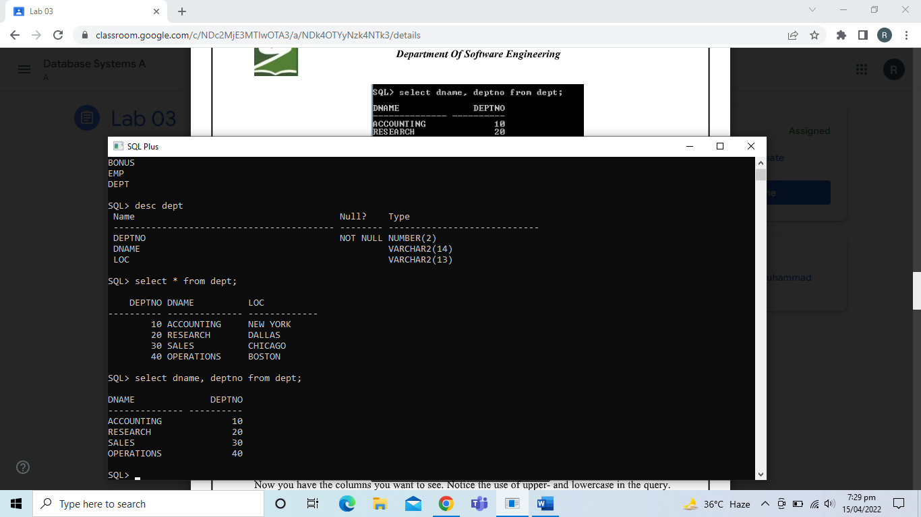

*Selecting Individual Columns:*

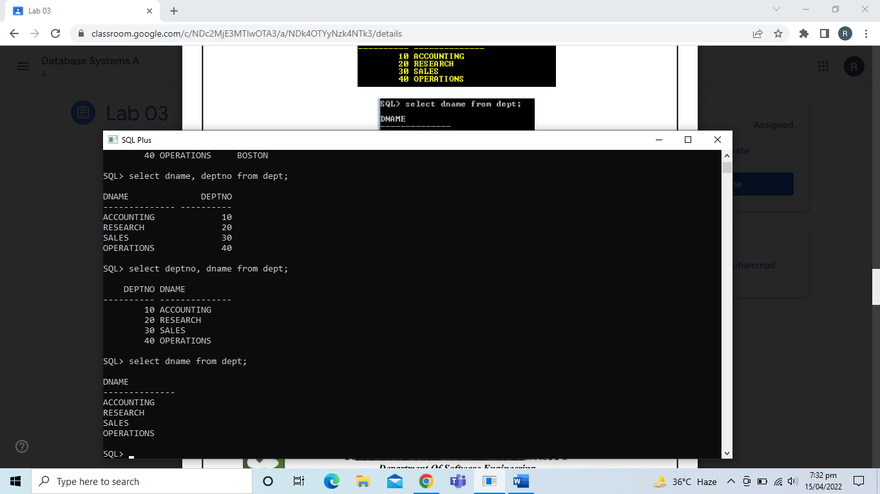

*Queries with Distinction:*

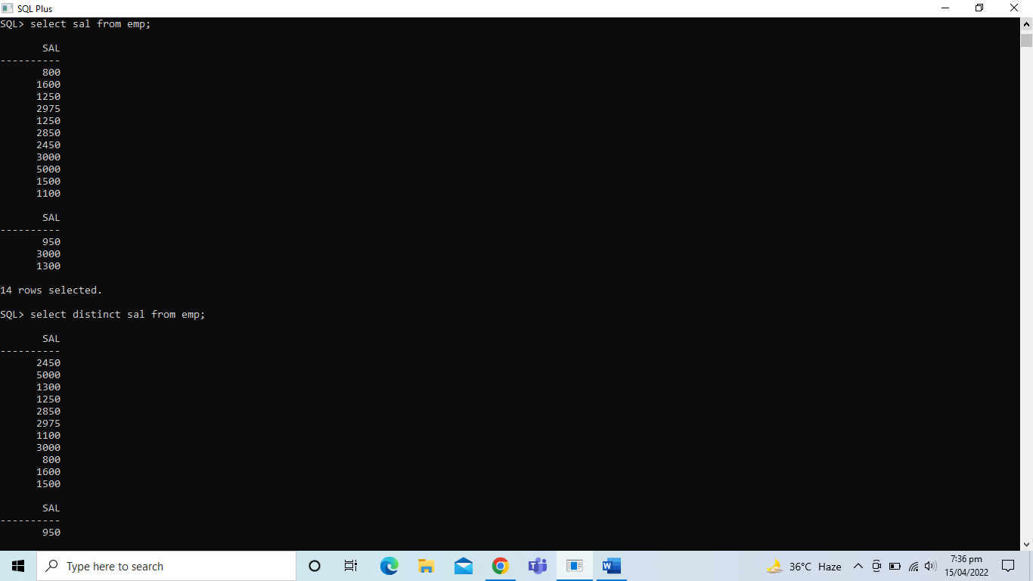

*The WHERE Clause:*

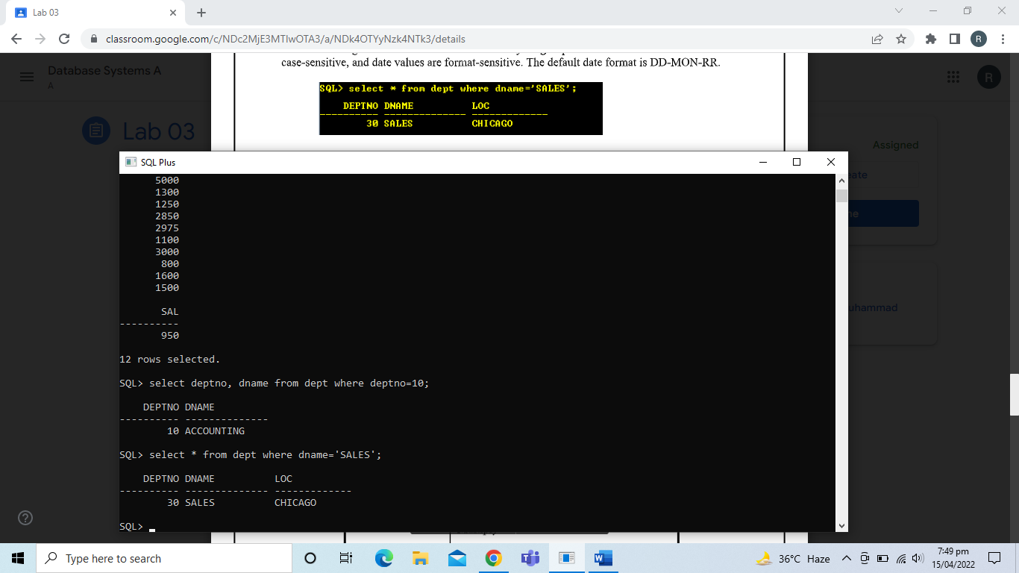

*Arithmetic Expressions:*

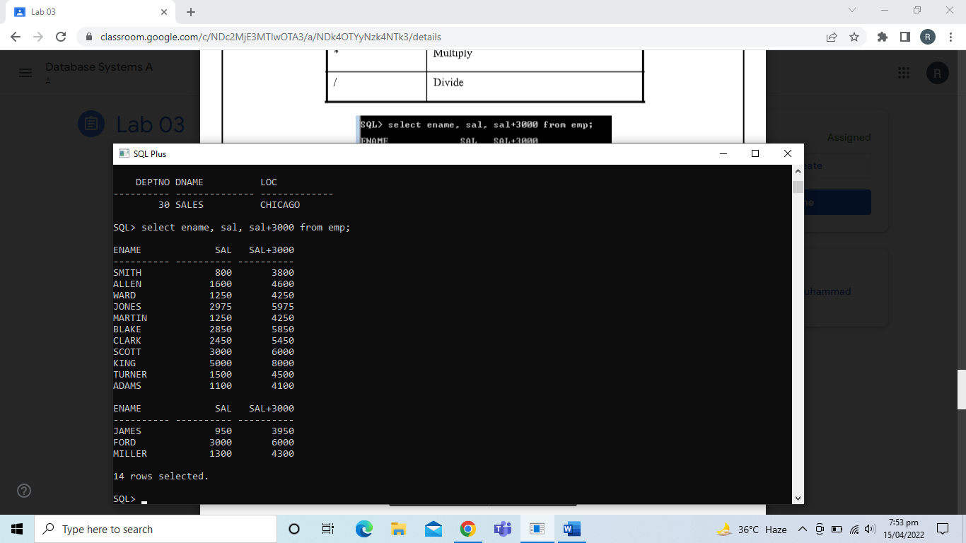

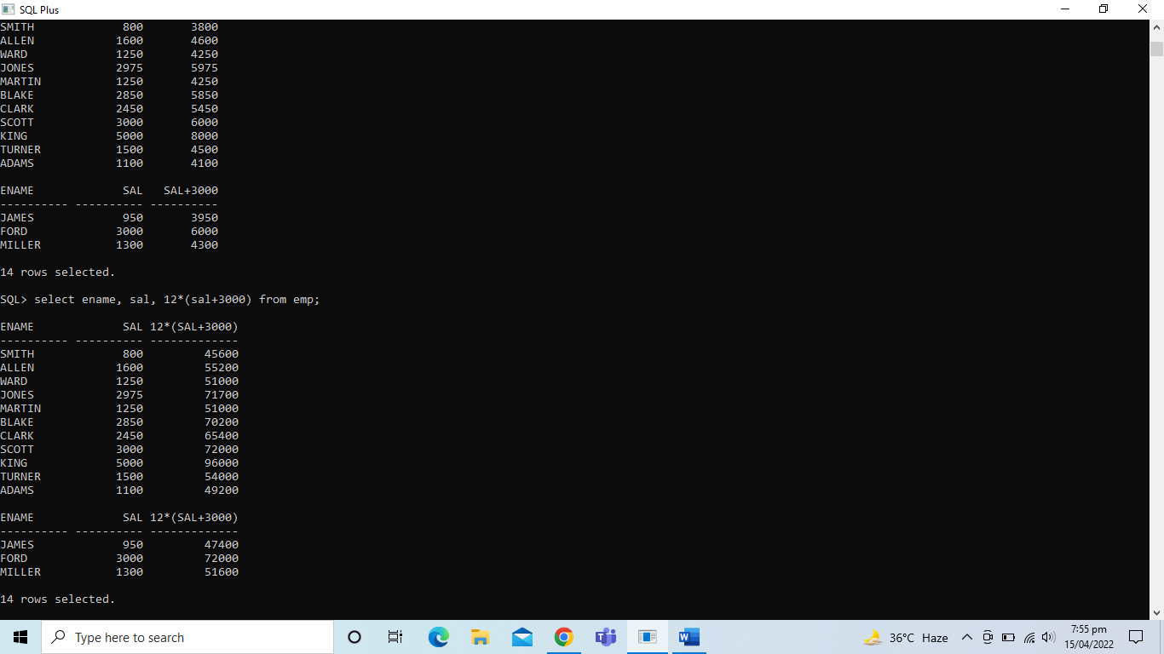

*Defining Column Alias:*

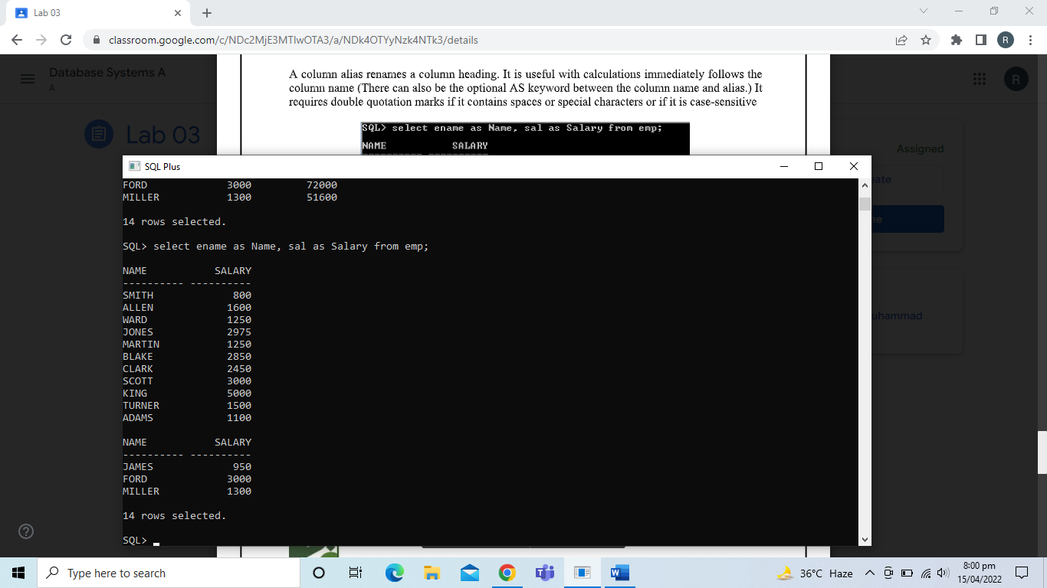

*Concatenation Operator:*

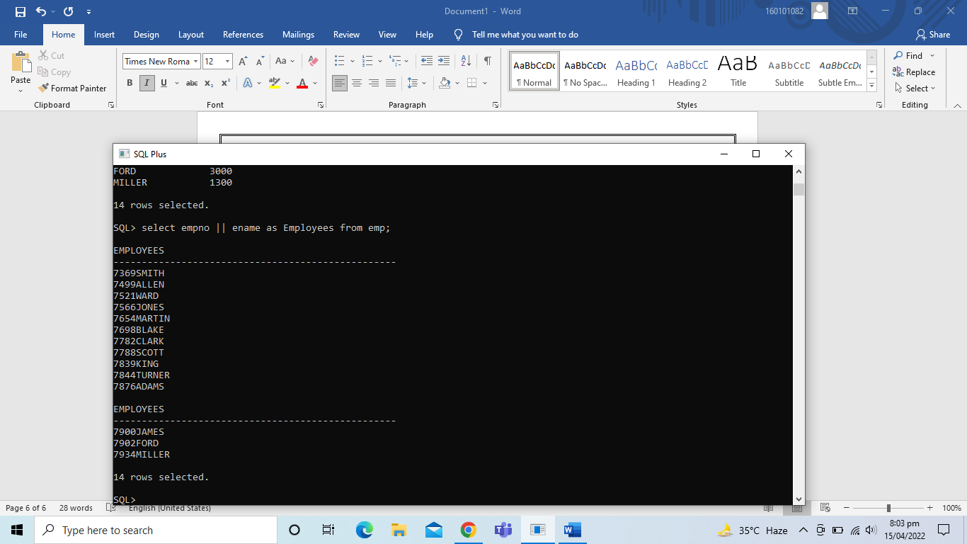

*Literal String:*

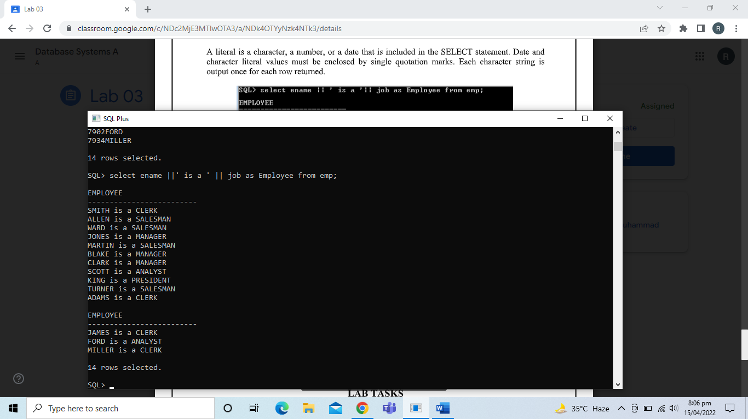

TASKS

1. **Do the following statements return the same or different output:**

**SELECT * FROM DEPT;**

**select * from dept;**

They return same output

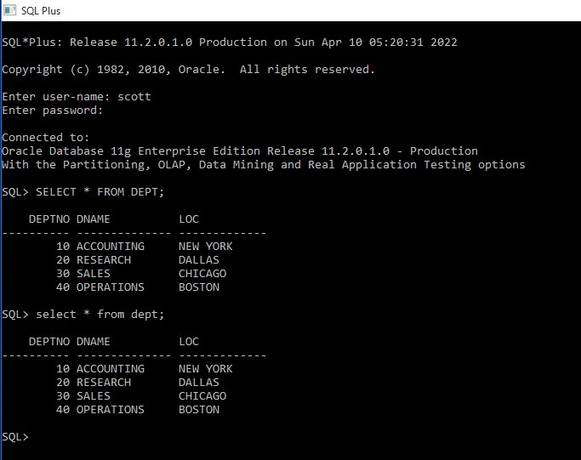

1. **The following queries do not work. Why not?**
2. **Select \***
3. **Select * from emp**
4. **Select empno ename FROM emp;**

Both a and b don’t work because their format is wrong.

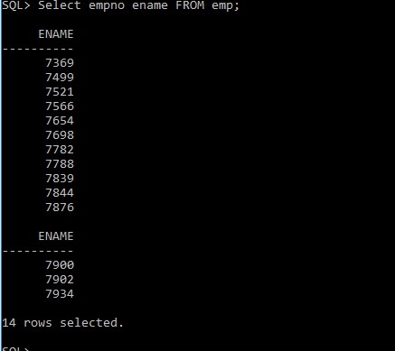

1. **Which of the following SQL statements will work?**
2. **select \***

**from salgrade;**

1. **select * from salgrade;**
2. **select * from salgrade**

Only statement b will work.

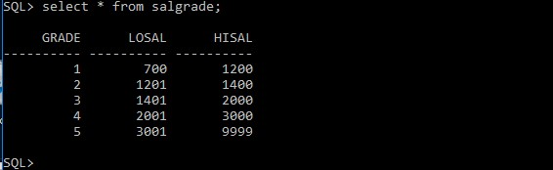

1. **There are four coding errors in this statement. Can you identify them?**

**SELECT empno, ename**

**Sal X 12 ANNUAL SALARY**

**FROM emp;**

Answer: The errors are **‘;’** , **‘,’** , **‘*’**

1. **Show the structure of the emp table. Select all data from the table.**

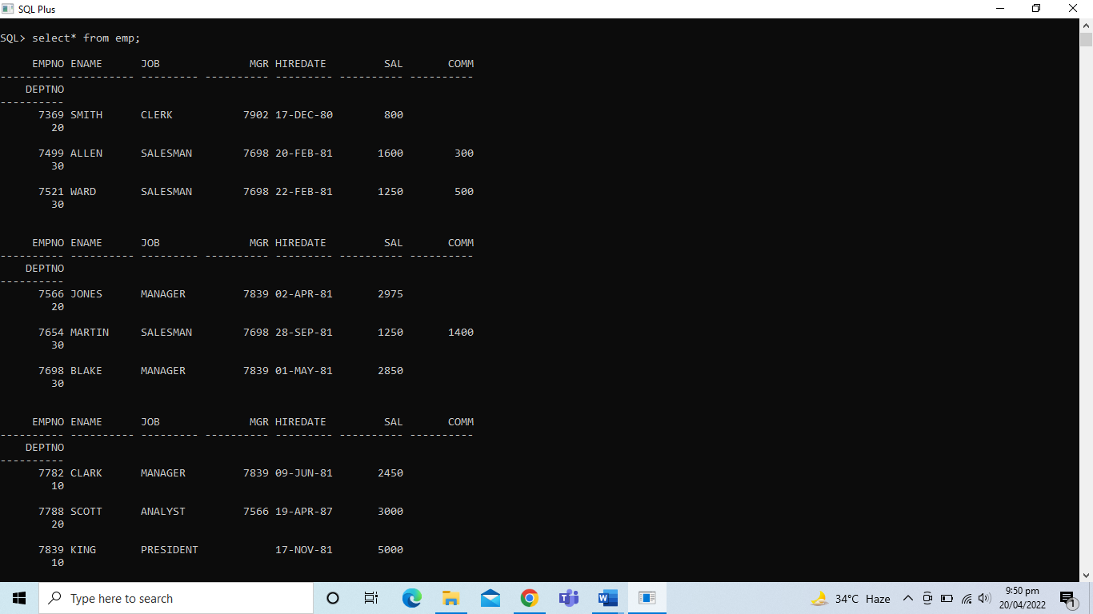

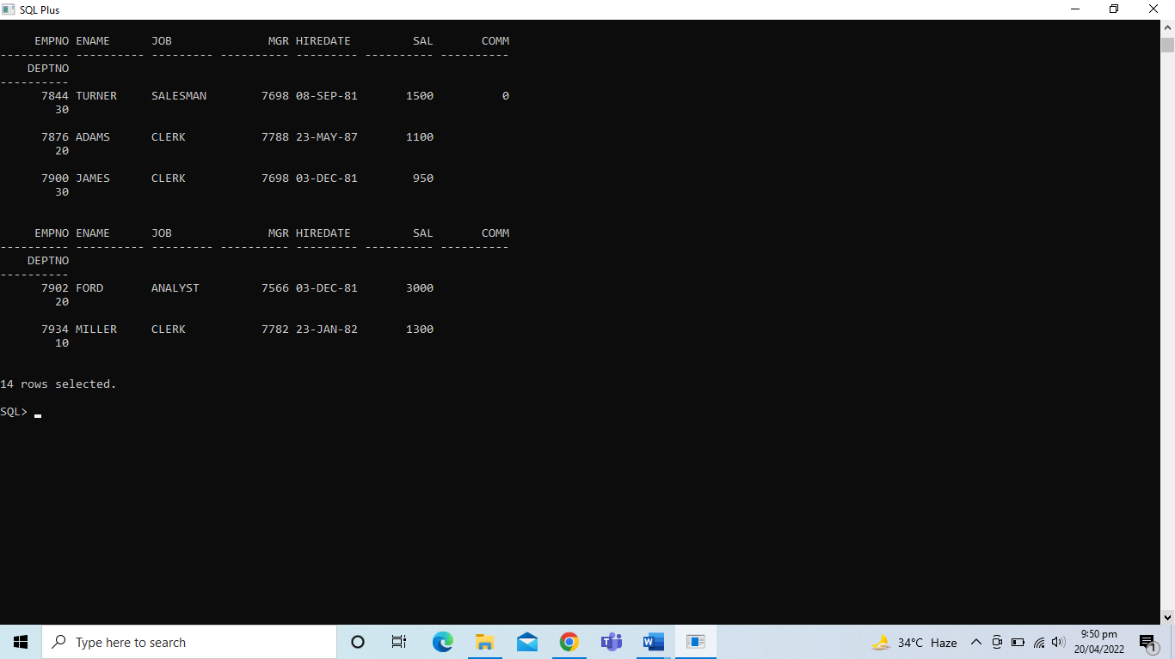

1. **Show the structure of the bonus table. Select all data from the table.**

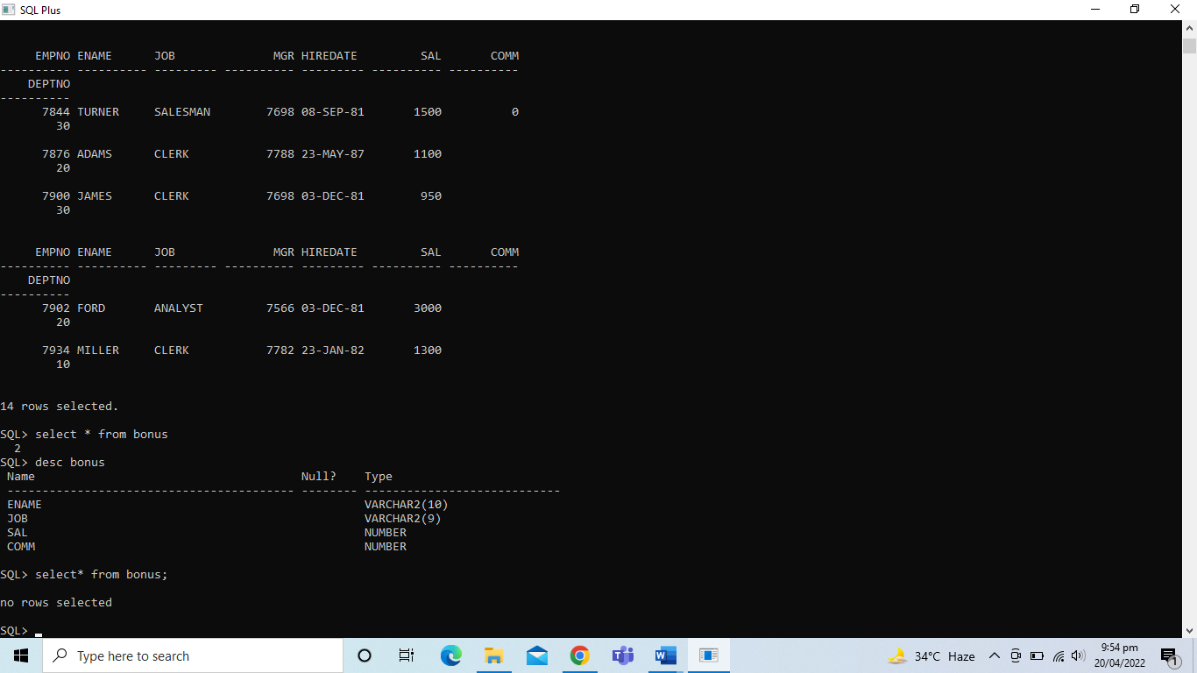

1. **Create a query to display the empno, hiredate, salary from the employee table**

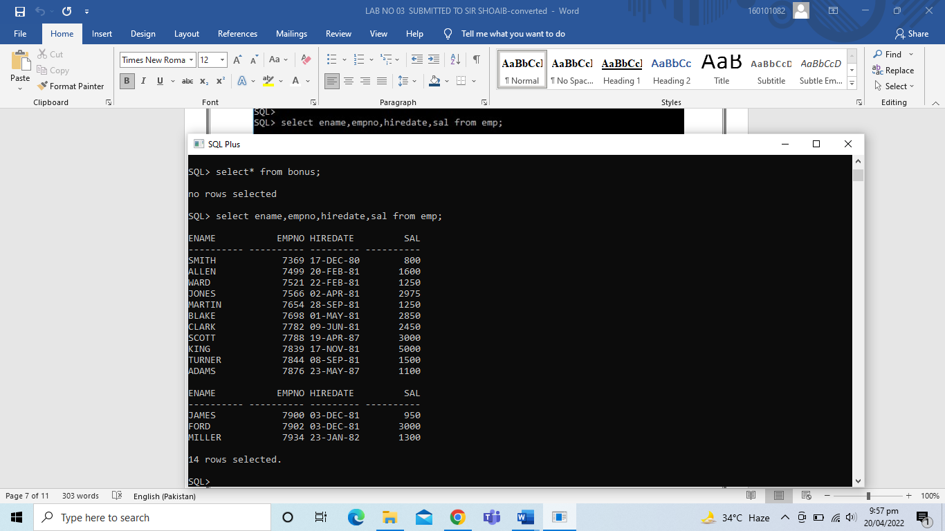

1. **Create a query to display the unique manager id from the employee table**

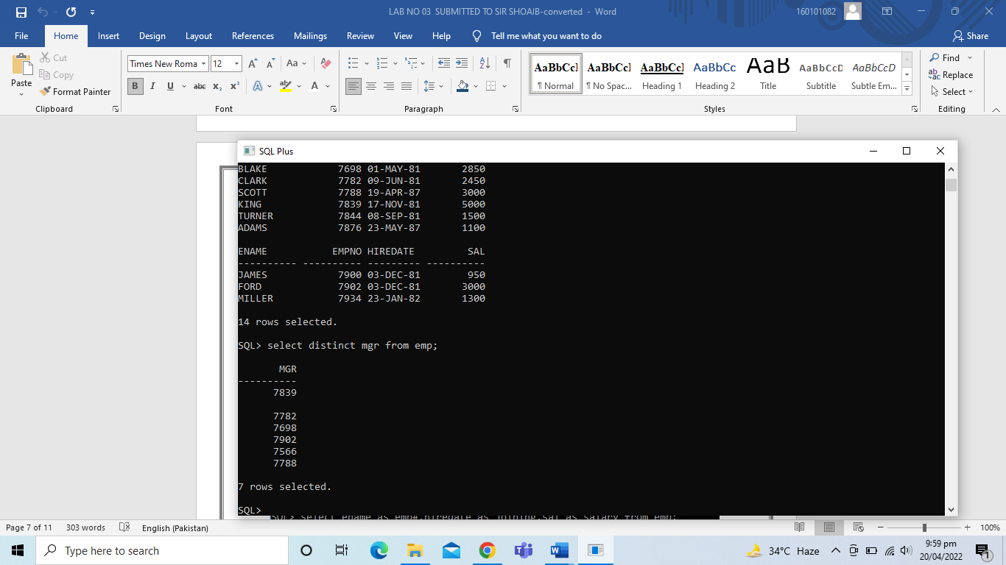

1. **Create a query to display the empno, hiredate, salary and rename column as Emp #, Joining Date, Salary from the employee table**

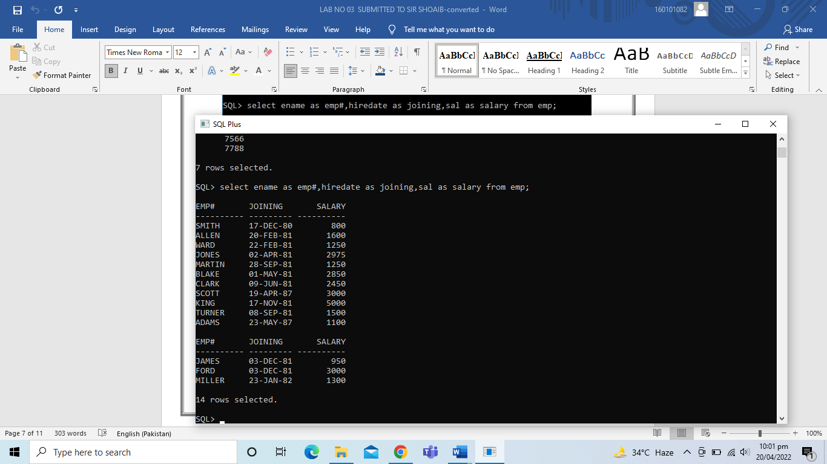

1. **Create a query to display all the data from the emp table. Separate each column by a comma.**

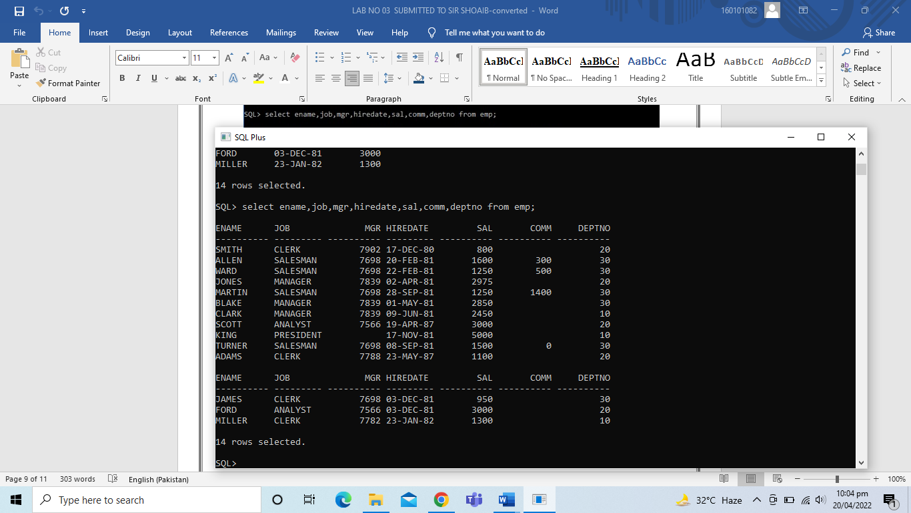

1. **Create a query that display the salary of employee with increment of 10%.**

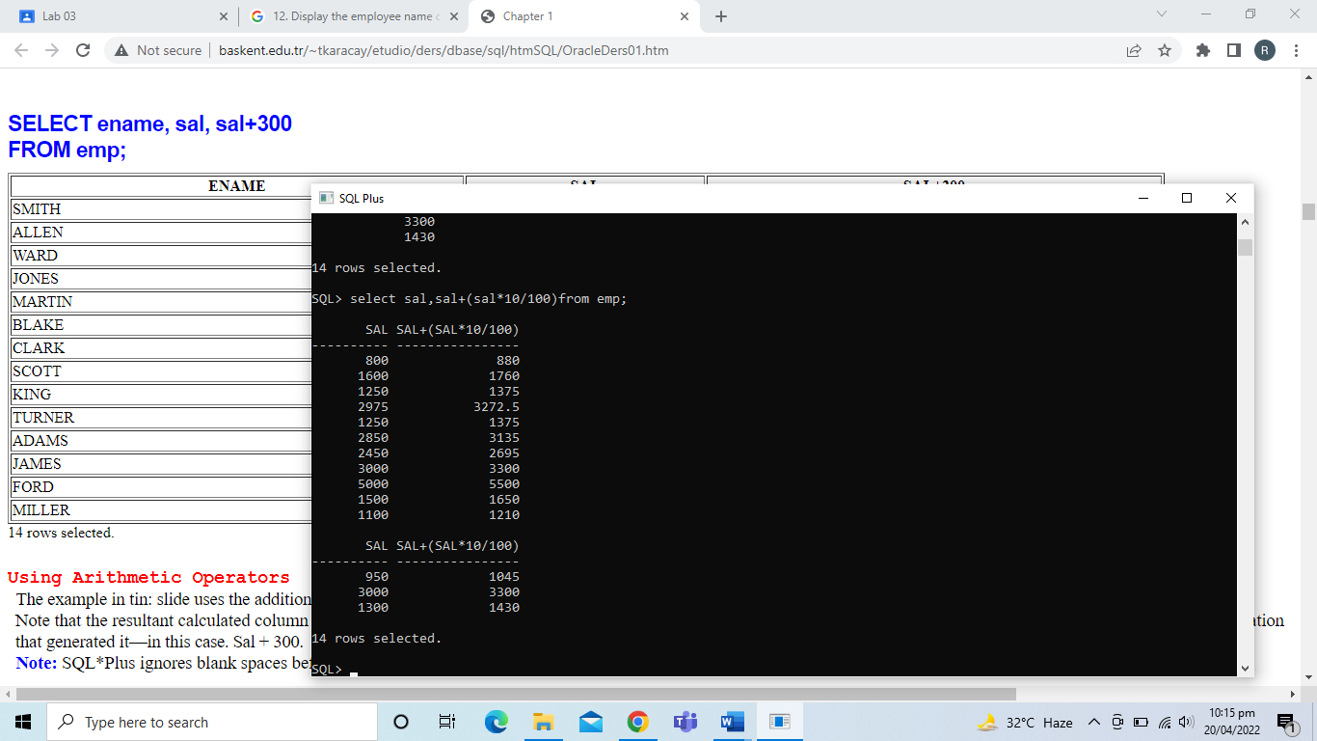

1. **Display the employee name concatenated with the job tile and hires date and names the column “Employee Details”.**

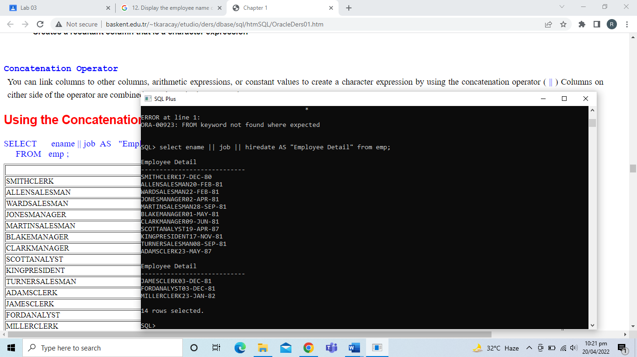

1. **Create a query that display the employee details of all employees whose designation is “CLERK”.**

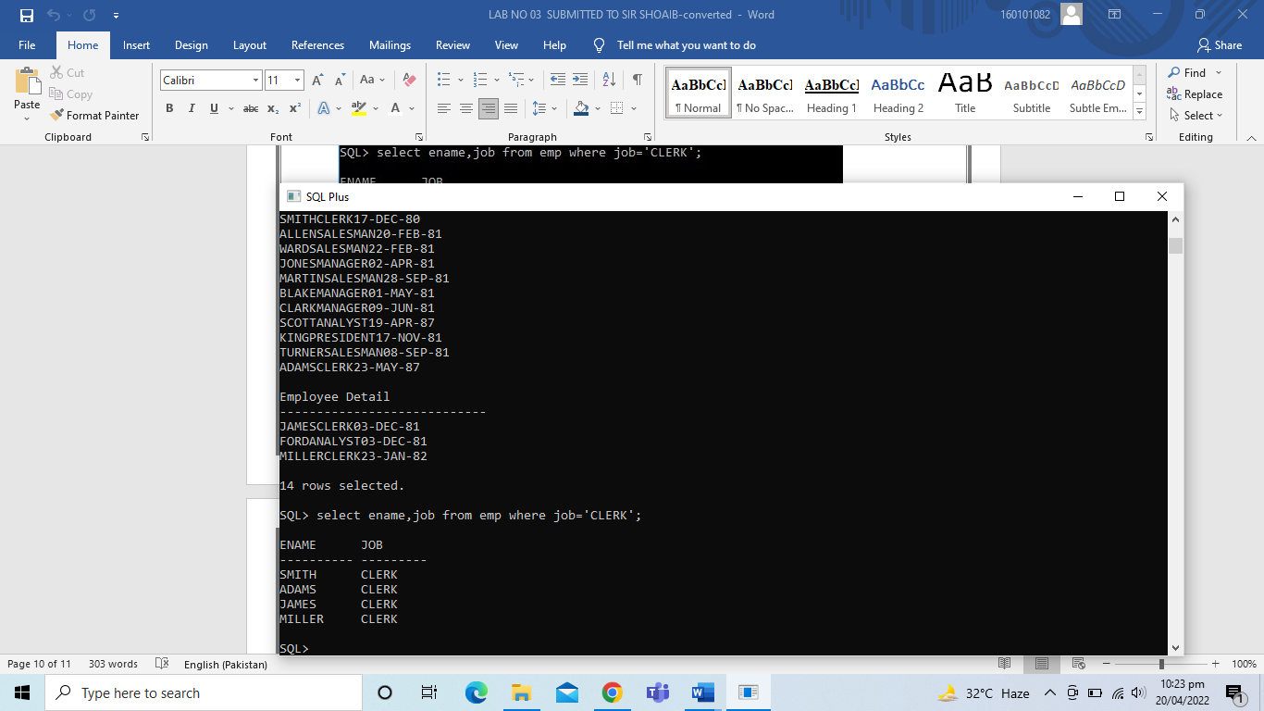

1. **Create a query that display the location of the department “OPERATIONS”**

